**PROJECT PROPOSAL**

**FOR**

**TITLE**

**PREPARED BY**

**KUNJAN PATEL**

**ALEXANDER PINTO**

**SHERIDAN COLLEGE**

**OVERVIEW**

The purpose of this application is to provide users the information needed to understand the background of each country. This application allows the user to select a certain Continent and a certain Country within that selection. An Add button will be given to the user on each page to allow them to add more information to the application that was missing. Once a Country is selected the application will show an image of the country and information on the side of the image. As well the user will be given a comment box to all the user to input more information about the country or even add personal experience they had with the Country.

**TECHNICAL OVERVIEW**

**Development Environment**

* IntelIJ IDEA 2019.3 editor - This integrate development environment used to write code with best practice.
* SceneBuilder - It is used to create layout and pages in application using ready to use GUI components. This builder is integrated with IntelIJ IDEA.
* JavaFX 11 – This library is intent to create GUI based application based on JAVA programming language.
* Java 11 JDK – Java Development Kit is base requirement in order to create any java-based application to run and test application.

**Application Content Design**

* File I/O – It is used to store list of continents and countries and retrieve back when user opens application again.
* Array List – This application has different list of countries and comments list. So, to access lists in application we use array list data type from java data types.

**User Interface**

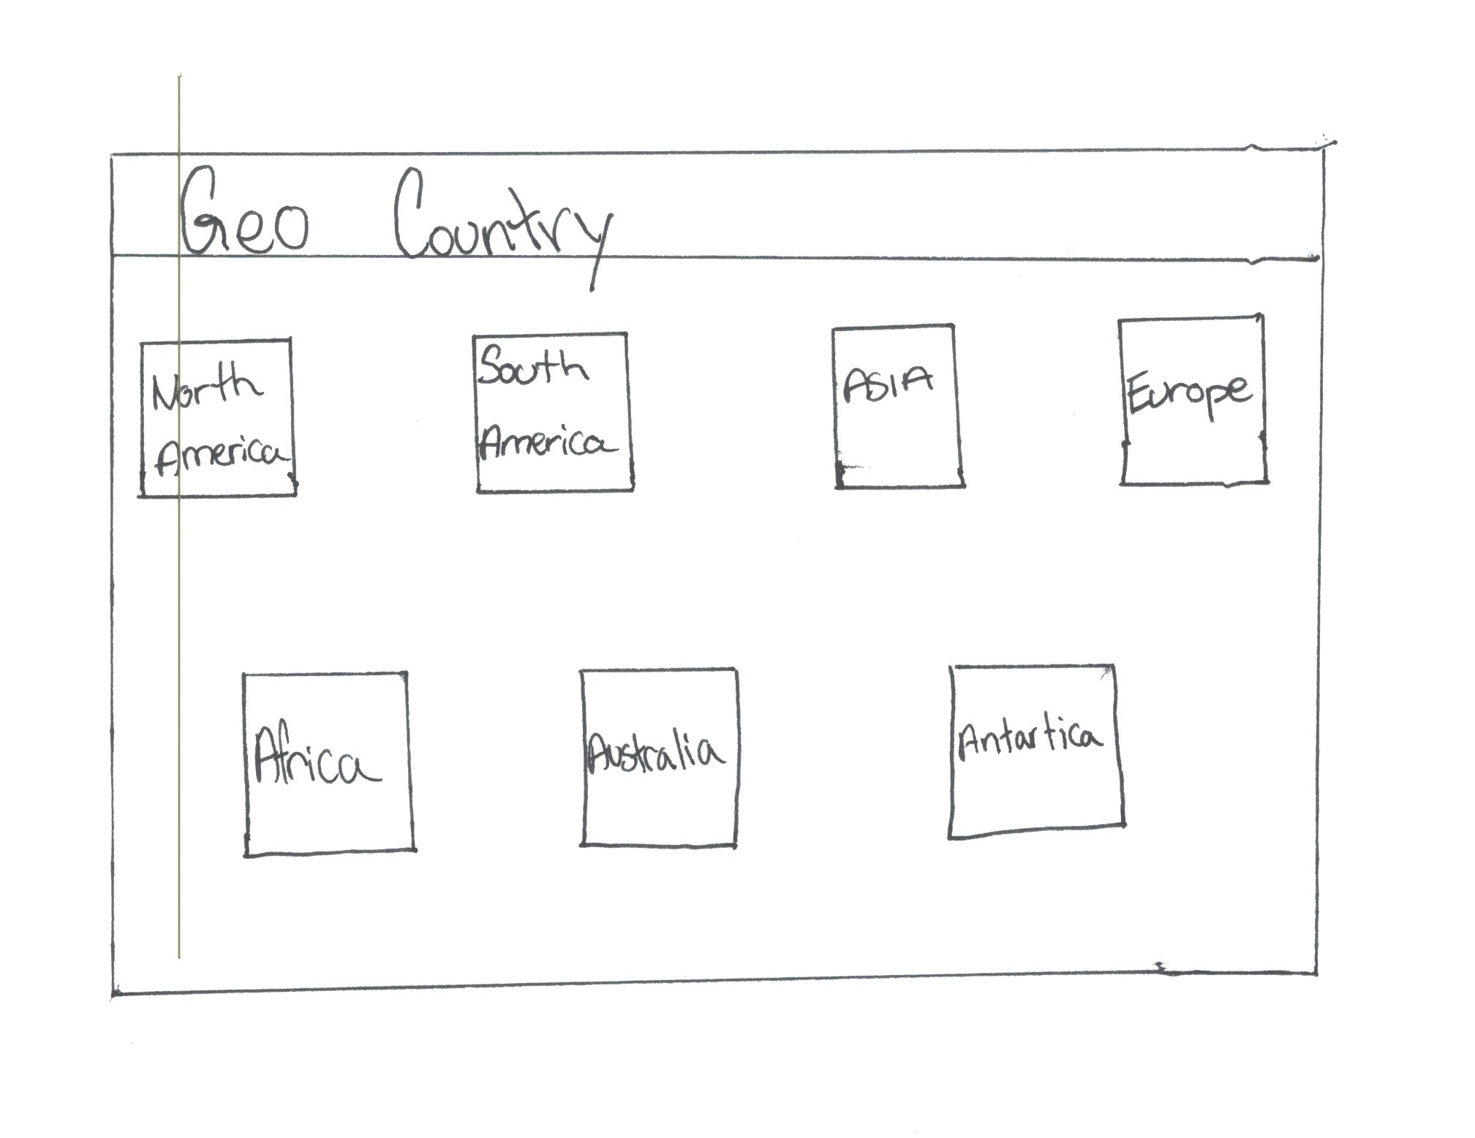

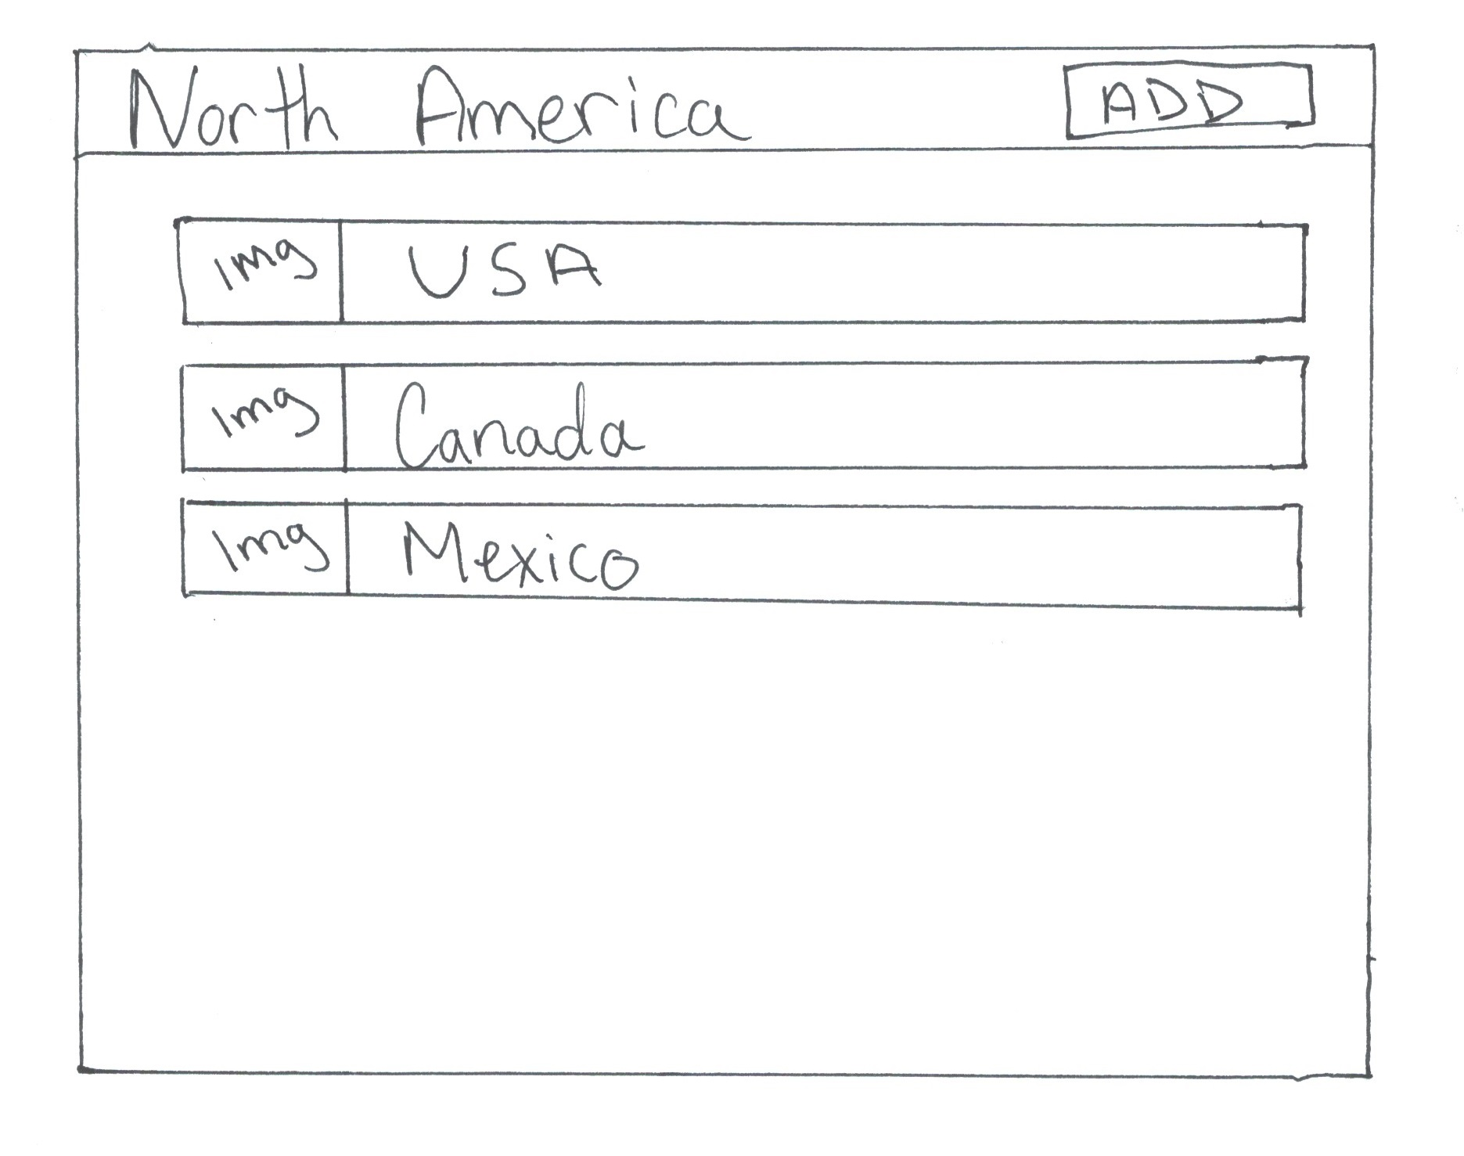

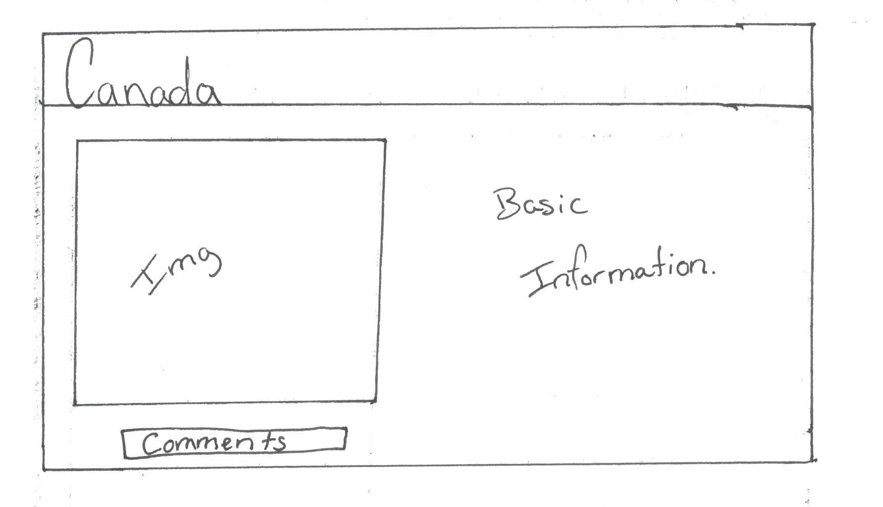

**UML DIAGRAMS**

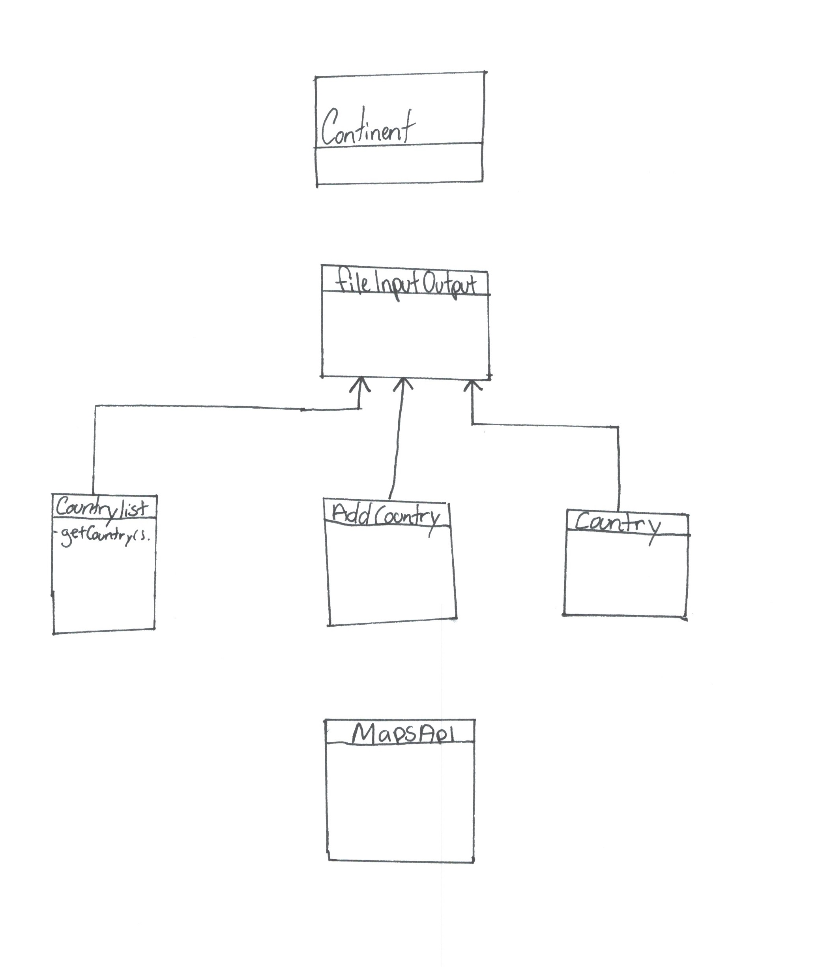

**DIVISION OF RESPONSIBILITIES**

The project responsibility is equally divided between both member which is mention below.

* **Alexander Pinto**
  + Create user interface design
  + Create UML diagram
  + Create continents page
  + Create countries list page
  + Create country information page
* **Kunjan Patel**
  + Create project proposal
  + Create file I/O class
  + Create add new country page
  + Create Maps API page